E-Commerce Analysis Using MySQL
Prepared as a portfolio case study demonstrating data preparation, SQL querying, KPI analysis, and business-oriented insights.

TOTAL SALES, TOTAL ORDERS AND AVG ORDER VALUE
SELECT
SUM(Total_Amount) AS total_sales,
COUNT(DISTINCT Order_ID) AS total_orders,
ROUND(SUM(Total_Amount) / COUNT(DISTINCT Order_ID),2) AS avg_order_value
FROM sales
WHERE Order_Status = 'Delivered';
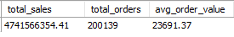

- Executive & Sales Revenue Analysis
How are total revenue, total order volume, and Average Order Value (AOV) trending month-over-month? Are there seasonal peaks?
SELECT
DATE_FORMAT(Order_Date, "%Y-%m") AS `Year_Month`,
COUNT(DISTINCT Order_ID) AS Total_Delivered_Orders,
ROUND((SUM(Total_Amount) / COUNT(Order_ID)),2) AS Average_Order_Value,
SUM(Total_Amount) AS Total_Sales,
LAG(SUM(Total_Amount)) OVER(ORDER BY DATE_FORMAT(Order_Date, "%Y-%m")) AS Previous_Month_Sales,
SUM(Total_Amount) - LAG(SUM(Total_Amount)) OVER(ORDER BY DATE_FORMAT(Order_Date, "%Y-%m")) AS MoM_Growth,
ROUND(((SUM(Total_Amount) - LAG(SUM(Total_Amount)) OVER(ORDER BY DATE_FORMAT(Order_Date, "%Y-%m")))
/ LAG(SUM(Total_Amount)) OVER(ORDER BY DATE_FORMAT(Order_Date, "%Y-%m"))) * 100, 2) AS MoM_Growth_Pct
FROM sales
WHERE Order_Status = 'Delivered'
GROUP BY `Year_Month`
ORDER BY `Year_Month`;

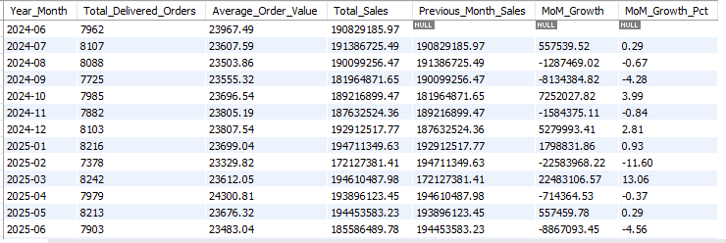
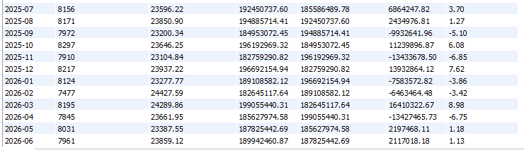

- Revenue Contribution by Product Category & Brand
Are the highest-selling brand also the highest-revenue products?
WITH ranked AS
(
SELECT
p.Category,
p.Brand,
SUM(s.Quantity) AS total_units_sold,
SUM(s.Total_Amount) AS total_sales,
ROUND(AVG(s.Coupon_Discount),2) AS avg_discount_given
FROM products as p
INNER JOIN sales as s
ON p.Product_ID = s.Product_ID
WHERE s.Order_Status = 'Delivered'
GROUP BY p.Category, p.Brand
)
SELECT
*,
DENSE_RANK() OVER(ORDER BY total_units_sold DESC) AS unit_rank,
DENSE_RANK() OVER(ORDER BY total_sales DESC) AS revenue_rank
FROM ranked;
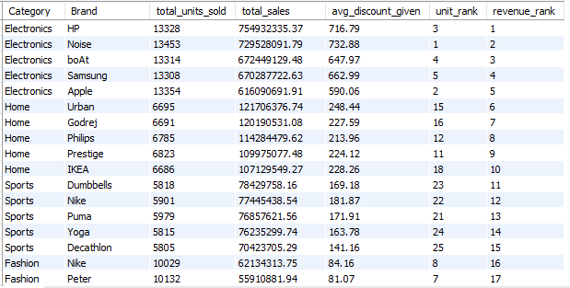
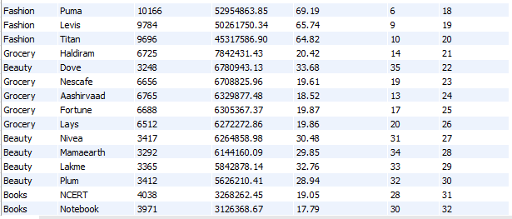
- Geographic Sales Distribution
Which states and top 10 cities generate the highest sales volume and revenue?
SELECT
State,
City,
COUNT(DISTINCT Customer_ID) AS total_customers,
COUNT(DISTINCT Order_ID) AS total_orders,
SUM(Quantity) AS total_units_sold,
SUM(Total_Amount) AS total_revenue
FROM sales
WHERE Order_Status = 'Delivered'
GROUP BY State, City
ORDER BY total_revenue DESC
LIMIT 10;
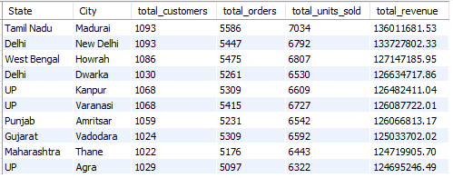

- Customer Tier & Lifetime Value (CLV)
How does total revenue and average spending vary across customer tiers (Gold, Silver, Platinum), and do higher tiers order more frequently?
SELECT
c.Customer_Tier,
SUM(s.Total_Amount) AS total_revenue,
ROUND(COUNT(DISTINCT s.Order_ID) / COUNT(DISTINCT c.Customer_ID),2) AS avg_order_count_per_customer,
ROUND(SUM(s.Total_Amount) / COUNT(DISTINCT c.Customer_ID),2) AS avg_spending_per_customer,
ROUND(SUM(s.Total_Amount) / SUM(SUM(s.Total_Amount)) OVER() * 100,2) AS revenue_contribution_pct
FROM customers AS c
INNER JOIN sales AS s
ON c.Customer_ID = s.Customer_ID
WHERE s.Order_Status = 'Delivered'
GROUP BY c.Customer_Tier
ORDER BY total_revenue DESC;
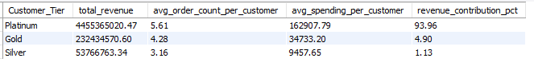

- Business Question: Which age groups and genders spend the most, and what categories do they prefer?
WITH cte AS
(
SELECT
c.Gender,
s.Customer_Age_Group,
p.Category,
COUNT(DISTINCT s.Order_ID) AS total_orders,
SUM(s.Quantity) AS total_units_sold,
SUM(s.Total_Amount) AS total_revenue
FROM customers AS c
INNER JOIN sales AS s
ON c.Customer_ID = s.Customer_ID
INNER JOIN products AS p
ON s.Product_ID = p.Product_ID
WHERE s.Order_Status = 'Delivered'
GROUP BY c.Gender, s.Customer_Age_Group, p.Category
ORDER BY total_revenue DESC
),
ranked_preference
AS
(
SELECT
*,
DENSE_RANK() OVER(PARTITION BY Gender, Customer_Age_Group ORDER BY total_revenue DESC) AS category_rank
FROM cte
)
SELECT
*
FROM ranked_preference
ORDER BY total_revenue DESC;

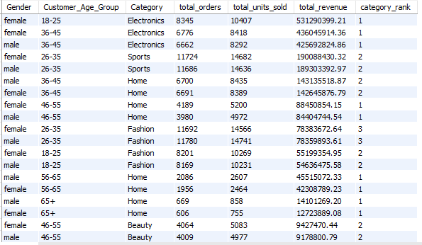

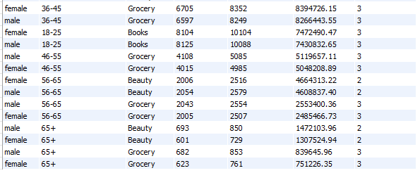

- Who are the top 20 customers by total spend, what is their preferred payment method, and when was their most recent order date?
WITH customer_sales AS
(
SELECT
c.Customer_ID,
c.Customer_Name,
SUM(s.Total_Amount) AS total_spend,
COUNT(s.Order_ID) AS total_order,
MAX(Order_Date) AS latest_order_date
FROM customers AS c
INNER JOIN sales AS s
ON c.Customer_ID = s.Customer_ID
WHERE s.Order_Status = 'Delivered'
GROUP BY c.Customer_ID, c.Customer_Name
),
payment_frequency AS
(
SELECT
s.Customer_ID,
s.Payment_Mode,
COUNT(s.Order_ID) AS mode_usage_count,
RANK() OVER (PARTITION BY s.Customer_ID ORDER BY COUNT(s.Order_ID) DESC, s.Payment_Mode ASC) AS payment_rank
FROM sales AS s
WHERE s.Order_Status = 'Delivered'
GROUP BY s.Customer_ID, s.Payment_Mode
)
SELECT
cs.Customer_ID,
cs.Customer_Name,
pf.Payment_Mode AS preferred_payment_mode,
cs.total_order,
ROUND(cs.total_spend, 2) AS total_spend,
latest_order_date
FROM customer_sales AS cs
INNER JOIN payment_frequency AS pf
ON cs.Customer_ID = pf.Customer_ID
WHERE payment_rank = 1
ORDER BY total_spend DESC
LIMIT 20;
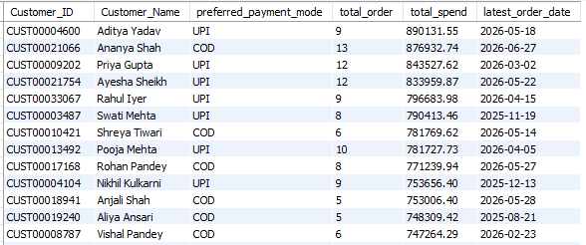
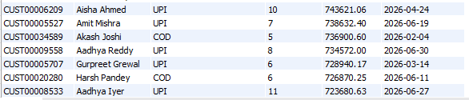

- What are the top 10 best-selling products by units sold versus revenue, and which items are in stock but underperforming?
WITH ranked_cte AS
(
SELECT
p.Product_ID,
p.Product_Name,
p.Stock_Quantity,
SUM(s.Quantity) AS total_units_sold,
SUM(Total_Amount) AS total_revenue
FROM products AS p
INNER JOIN sales AS s
ON p.Product_ID = s.Product_ID
WHERE s.Order_Status = 'Delivered'
GROUP BY p.Product_ID, p.Product_Name, p.Stock_Quantity
)
SELECT
*,
DENSE_RANK() OVER(ORDER BY total_units_sold DESC) AS unit_rank,
DENSE_RANK() OVER(ORDER BY total_revenue DESC) AS revenue_rank
FROM ranked_cte;

- WHICH ITEMS ARE IN STOCK BUT UNDERPERFORMING
WITH ranked_cte AS
(
SELECT
p.Product_ID,
p.Product_Name,
p.Stock_Quantity,
SUM(s.Quantity) AS total_units_sold,
SUM(Total_Amount) AS total_revenue
FROM products AS p
INNER JOIN sales AS s
ON p.Product_ID = s.Product_ID
WHERE s.Order_Status = 'Delivered'
GROUP BY p.Product_ID, p.Product_Name, p.Stock_Quantity
),
ranked_products AS
(
SELECT
*,
DENSE_RANK() OVER(ORDER BY total_units_sold DESC) AS unit_rank,
DENSE_RANK() OVER(ORDER BY total_revenue DESC) AS revenue_rank,
CASE
WHEN Stock_Quantity > 800 AND total_units_sold < 150 THEN 'High Stock / Underperforming'
WHEN Stock_Quantity < 50 AND total_units_sold > 200 THEN 'Stockout Risk / High Demand'
ELSE 'Healthy'
END AS inventory_status
FROM ranked_cte
)
SELECT
*
FROM ranked_products
WHERE inventory_status = 'High Stock / Underperforming'
ORDER BY Stock_Quantity DESC;

- Do higher product discount percentages (Discount_Percent lead to significantly higher sales volume, or do they negatively affect customer review ratings?
WITH cte AS
(
SELECT
p.Product_ID,
p.Product_Name,
p.Discount_Percent,
CASE
WHEN p.Discount_Percent BETWEEN 0 AND 10 THEN "0-10%"
WHEN p.Discount_Percent BETWEEN 11 AND 25 THEN "11-25%"
WHEN p.Discount_Percent BETWEEN 26 AND 50 THEN "26-50%"
END AS discount_brackets,
s.Order_ID,
s.Quantity,
s.Rating
FROM products AS p
INNER JOIN sales AS s
ON p.Product_ID = s.Product_ID
WHERE s.Order_Status = 'Delivered'
)
SELECT
discount_brackets,
COUNT(DISTINCT Product_ID) AS total_products,
COUNT(Order_ID) AS total_orders,
SUM(Quantity) AS total_units_sold,
ROUND(AVG(Quantity), 3) AS avg_quantity_per_order,
ROUND(AVG(Rating), 2) AS avg_customer_rating
FROM cte
GROUP BY discount_brackets
ORDER BY discount_brackets DESC;
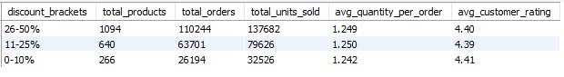

- Business Question: What percentage of total orders result in returns or cancellations, and which product categories or cities exhibit the highest return rates?
SELECT
p.Category,
s.City,
COUNT(s.Order_ID) AS total_orders,

-- Delivered
SUM(CASE WHEN s.Order_Status = 'Delivered' THEN 1 ELSE 0 END) AS total_delivered_orders,

-- Returned
SUM(CASE WHEN s.Order_Status = 'Returned' THEN 1 ELSE 0 END) AS total_returned_orders,
ROUND((SUM(CASE WHEN s.Order_Status = 'Returned' THEN 1 ELSE 0 END) * 100.0) / COUNT(s.Order_ID), 2) AS return_rate_pct,

-- Cancelled
SUM(CASE WHEN s.Order_Status = 'Cancelled' THEN 1 ELSE 0 END) AS total_cancelled_orders,
ROUND((SUM(CASE WHEN s.Order_Status = 'Cancelled' THEN 1 ELSE 0 END) * 100.0) / COUNT(s.Order_ID), 2) AS cancelled_rate_pct

FROM products AS p
INNER JOIN sales AS s
ON p.Product_ID = s.Product_ID
GROUP BY p.Category, s.City
ORDER BY return_rate_pct DESC;

- Business Question: What is the average delivery lead time (days between Order_Date and Delivery_Date), and does longer delivery time correlate with lower customer ratings?
WITH cte AS
(
SELECT
Rating,
DATEDIFF(Delivery_Date, Order_Date) AS days_delivered
FROM sales
WHERE Order_Status = 'Delivered'
)
SELECT
CASE
WHEN days_delivered <= 3 THEN "1-3 Days"
WHEN days_delivered BETWEEN 4 AND 5 THEN "4-5 Days"
ELSE "6+ Days"
END AS delivery_duration,
COUNT(*) As total_delivered_orders,
ROUND(AVG(days_delivered),2) AS avg_lead_time,
ROUND(AVG(Rating),2) AS avg_rating
FROM cte
GROUP BY delivery_duration;
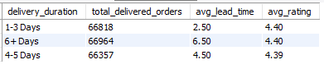

- What is the breakdown of preferred payment modes (COD, UPI, Credit Card, Debit Card), and do digital payment methods have higher average transaction values than Cash on Delivery?
SELECT
Payment_Mode,
COUNT(Order_ID) AS total_order,
SUM(Total_Amount) AS total_revenue,
ROUND(AVG(Total_Amount),2) AS avg_order_value
FROM sales
WHERE Order_Status = 'Delivered'
GROUP BY Payment_Mode
ORDER BY avg_order_value DESC;
